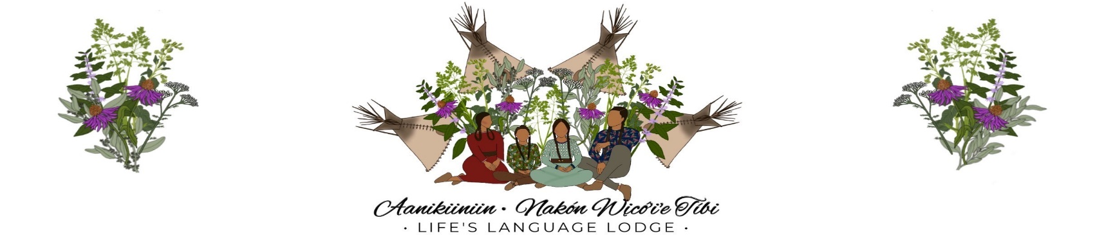
Life’s Language Lodge
Childcare Application 2024-2025
353 Old Hays Road | PO Box 525 | Hays, MT 59527 Tel: (406) 673-3850 | www.lifeslanglodge.com

Please Fill out and provide all information and documentation necessary for each section.
Are you an IMDG employee? Yes____ No____
Child’s Name: ___________________________ Gender: Male____ Female____ Date of Birth: ____/____/_________
Child’s Tribal Affiliation(s): ______________________________________________________ Parent/Guardian Name:_________________________________________________________
Address: ______________________________________________________________________
City: _________________________ State: ___________________ Zip Code:_______________
Home: ____________________ Cell: _____________________ Work: ____________________ Email Address: ______________________________________
Tribal Affiliation(s): _____________________________________________________________
Parent/Guardian Name: ________________________________________________________
Address: ______________________________________________________________________
City: _________________________ State: ___________________ Zip Code:_______________
Home: ____________________ Cell: _____________________ Work: ____________________ Tribal Affiliation(s): _____________________________________________________________

Emergency Contacts:
Name: _________________________________________ Phone:_________________________ Address: ______________________________________________________________________ Relationship to child/parents/guardians: _____________________________________________
Name: _________________________________________ Phone:_________________________ Address: ______________________________________________________________________
Relationship to child/parents/guardians: _____________________________________________

Our Vision statement is:

“behíííh byiitɔ’ɔ’ɔ́wuh ’íitɔɔtɔɔh tɔwɔcinnítééih nííθénɔɔ’ nɔh
néinɔɔ’ tɔwɔcinnítáááninɔɔ’ téi’ítaahaach”

“maká idómni nakón wicóȟage otéȟige adé iná
namákoda žemáca mnihéiciya no.”

With the purpose of achieving this mission, at least one of the parents/guardians of any enrolled child must be an active learner of either the Aaniiih or Nakoda language. Children whose parents/guardians who are not actively learning and speaking Aaniiih or Nakoda may not enroll or continue to attend Life’s Language Lodge school. Parents/Guardians can meet their annual obligation to learn and speak Aaniiih or Nakoda by:
- Having exhibited increased fluency in Aaniiih or Nakoda as determined by the Project Director of Life’s Language Lodge or their designee (verbal test);
- Enrolling in and completing 60 hours of Aaniiih or Nakoda classes annually, with a monthly average of 6 hours. Classes are provided throughout the school year at no cost by Life’s Language Lodge.
Parent/Guardian Name: _____________________________________________________
Do you speak Aaniiih or Nakóda? Yes________ No __________
If so which Language? _____________________________________
Parent/Guardian Name: _____________________________________________________
Do you speak Aaniiih or Nakóda? Yes________ No __________
If so which Language? _____________________________________
If your child is accepted in LLL, how will you the parent(s)/guardian(s) be an active participant in the learning and promotion of our languages?
______________________________________________________________________________
______________________________________________________________________________ I/We, the undersigned, have read and understood the Aaniiih/Nakoda Obligation form and affirm that in order to maintain my/our child(ren)’s eligibility to attend Life’s Language Lodge I/we will demonstrate advanced fluency in Aaniiih or Nakoda or I/we will complete 60 hours of Aaniiih/Nakoda classes during the 2024-2025 school year with a monthly average of 6 (six) hours per month.
_________________________________________ | ________________________
Parent- Guardian signature | Date
__________________________________________ | ___________________________
Parent – Guardian signature | Date

Holiday Schedule 2026
New Years Day 1st day of the year
Martin Luther King Day 3rd Monday January
Presidents’ Day 3rd Monday in February
Easter (Friday before and Monday following Easter)
Memorial Day, last Monday in May
Independence Day, July 4th
Labor Day, 1st Monday in September
Native American Day, 4th Friday in September
Indigenous People’s Day, October 14th
Veterans Day, November 11th
Thanksgiving Day, 4th Thursday in November and the Friday preceding
Christmas Eve, December 24th
Christmas Day, December 25th
Absences/Holidays 1. Life’s Language Lodge will not add make-up days to the school calendar nor refund tuition for closures due to emergencies, snow days, or other unexpected or weather conditions. 2. There are no make-up days or reductions in tuition for child absences due to illness, emergencies, family vacations, or other absences. 3. There are no tuition reductions or make-up days for Thanksgiving, Christmas or for Spring, June, or Summer Breaks, holidays, nor for professional development days. Tuition is for the entire school year and is payable monthly as a convenience to parents.
Payment 1. If paid monthly, tuition is due on the first day of the month in which care and education is to be provided. 2. If tuition is not paid on time, parents/guardians must make arrangements with the Life’s Language Lodge administration before bringing a child for care for an unpaid month. Care cannot be provided for children for whom tuition payments or arrangements have not been made. 3. LLL accepts cash, checks, money orders and credit/debit cards. A fee of $30.00 is charged for returned checks.
____________________________________ | _________________________
Parent/Guardian signature | Date
____________________________________ | __________________________
Parent/Guardian signature | Date

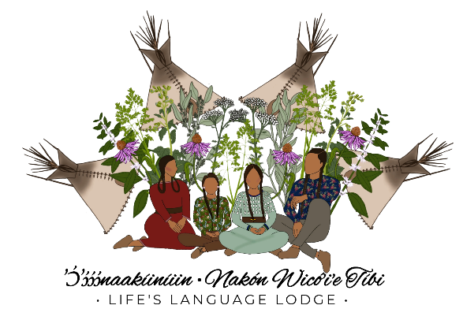

Student Counseling Policy

Life’s Language Lodge has the goal of providing the best educational experiences possible, designing, and implementing a variety of educational, cultural and social programs to meet the unique needs of each of our students. Our goal is for our students to have a strong, healthy sense of self, to be confident, life-long learners, and to be cultural leaders who serve and empower their communities. In keeping with these goals, our teaching and social services staff will meet with students from time to time to assist them in their personal, educational and social development, including offering academic, cultural and personal counseling. Academic and cultural counseling will be performed by instructional, cultural, administrative staff, and personal counseling will be performed by licensed school or therapeutic counselors or counseling interns under the supervision of LLL staff. Usually, parents will not be contacted prior to their students receiving routine counseling at school. If students are identified as having an extraordinary need for therapeutic personal counseling, LLL administration will reach out to parents and notify them of such counseling services so that parents are aware of the counseling services being provided by the school and can be part of the plan to assist and empower their child.
I _____________________________________ the parent guardian of
____________________________
Do hereby acknowledge and receive an understanding of the above LLL student counseling policy.
______________________________________________________________________________
Parent- Guardian signature Date
______________________________________________________________________________
Parent- Guardian signature Date

Photo Video Release Form

Life’s Language Lodge (LLL) participates in Early Achievers, ECEAP, EWU Transition to Teaching, and other professional development programs. These programs require photographs, videos, and observations of the children, parents, volunteers, visitors, and staff of LLL. LLL also uses images of students, staff, and families to promote our mission and raise funds. Therefore, we ask that parents grant permission for LLL to use and share images of children and families for the purposes of advancing our mission.
I, the undersigned, hereby grant permission for Life’s Language Lodge, its employees, agents or volunteers to photograph and/or video my child ______________________ for the purposes of promoting the school's mission. I understand the photos and videos may (or may not) be used for evaluation, curriculum and publicity purposes or any other use Life’s Language Lodge intends, which may include print, web and broadcast curriculum and publicity materials or other curriculum or publicity purposes. I acknowledge that there will be no notice given to me as to when or how Life’s Language Lodge may use photos/videos. Children will not be identified by their English name in any publication of photos without the written consent of the parent/guardian.
Upon request, any photos or videos taken will be freely shared with the parents of depicted children, but photos and videos shall be the sole property of Life’s Language Lodge. By signing below, I acknowledge that I have received a copy of this release form and agree to all conditions herein.
______________________________________________________________________________
Parent – Guardian signature Date
______________________________________________________________________________
Parent – Guardian signature Date

